## The value of a portfolio

The portfolio is one of the most important tools to promote your talent and skill as a creative practitioner. It is therefore critical that your portfolio is up to date and has all of the supporting information required by the person you are sharing it with. For example, sharing it with a client should contain the client brief, development plans, research, etc.

There are many reasons why creating a portfolio is immensely valuable for designers. Some of the reasons include showcasing your skills and style, building credibility, highlighting your experience and expertise, and most importantly, to advance your career. For this reason, quality is more important than quantity, and your portfolio should only show your very best projects. Ideally, your portfolio shows a selection of projects from start to finish, allowing the viewer to understand your creative thinking, methodology and research as well as your ability to interpret a brief.

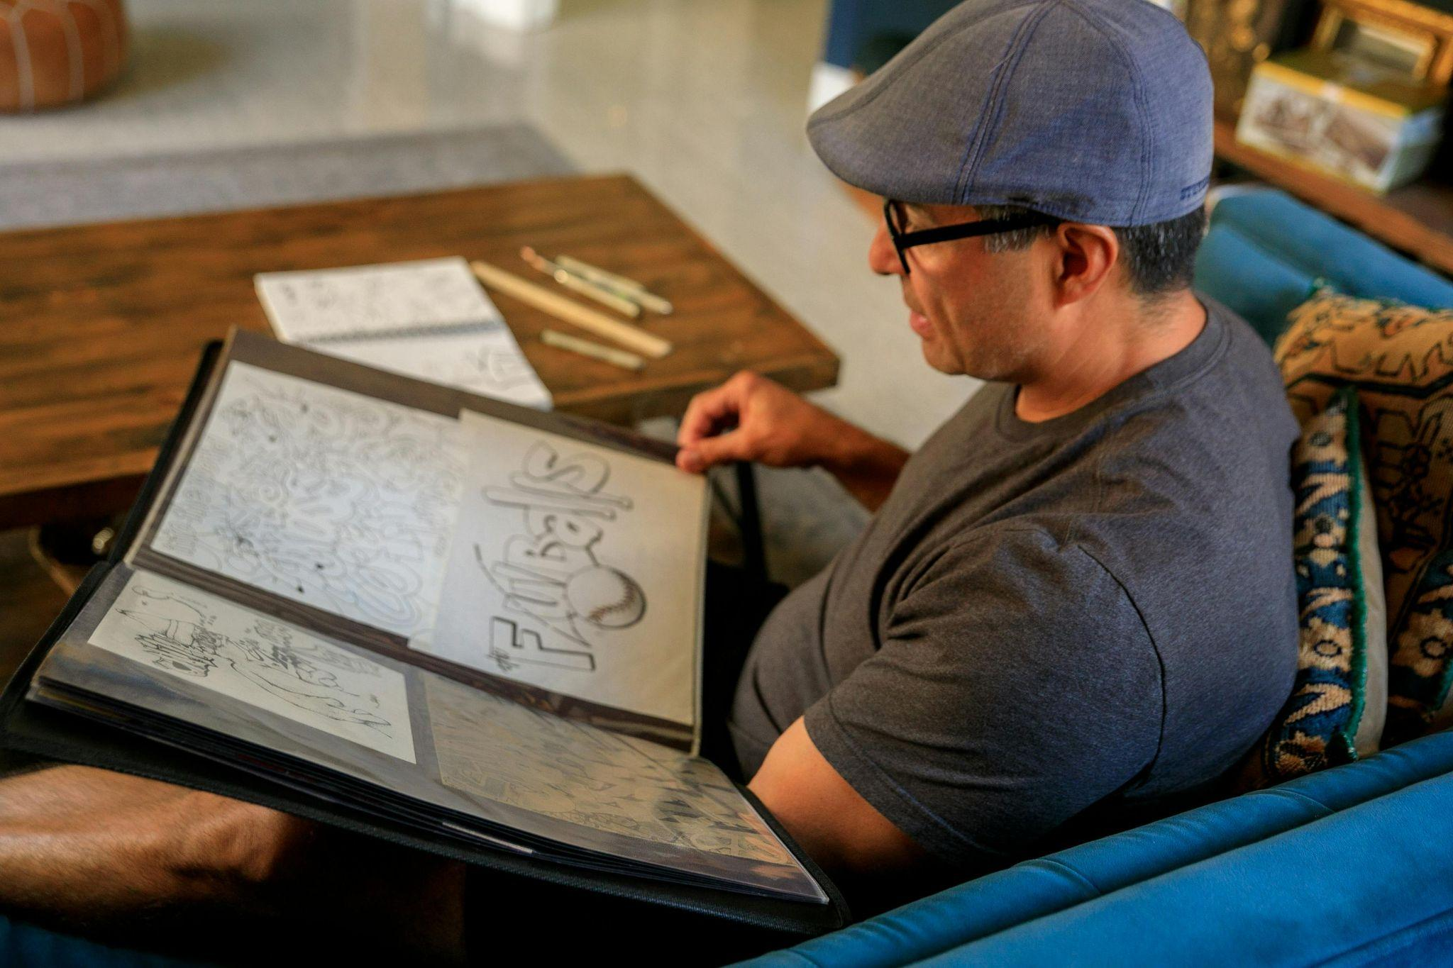

Fig 1. Unsplash (n.d) Example of a non-digital portfolio

Creative portfolios can take various forms each tailored to the designer's preferences, the nature of their work, and the target audience. The different types of portfolio include:

* Printed
* Digital
* PDF
* Interactive
* Video

## What to include in a portfolio

A good design portfolio should include a variety of elements to showcase your work. This can be either client work such as real-world projects you've completed for clients, or personal projects. It should also include work that demonstrate your creativity, your passion, and your ability to work independently, or a combination of both.

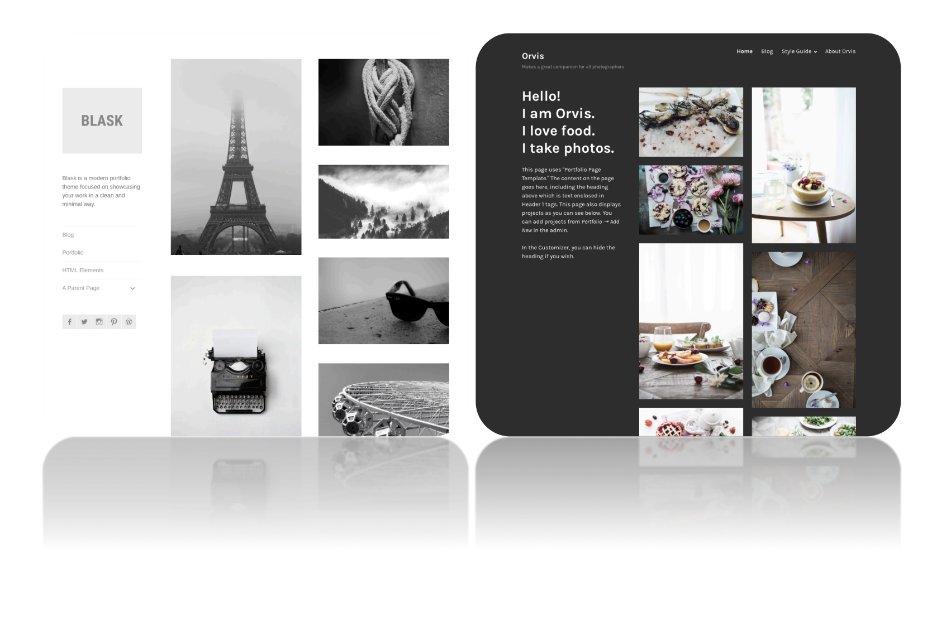

Fig 2. Example of a digital design portfolio

Regardless of the work you choose to showcase, your portfolio needs to contain the following:

#### **Introduction**

A professional design portfolio opens with a brief introduction that provides an overview of your design philosophy, goals, and values. This sets the stage for your portfolio and gives viewers (e.g. potential employer, client, etc.) a sense of your approach to creative problems.

#### **Personal branding**

If you have a personal logo, branding, or identity, this should also be displayed throughout the entire portfolio. This creates a cohesive and memorable presentation.

#### **Best work**

This is the most important aspect of portfolio presentation. You need to carefully select a series of your best and most relevant designs and/or visuals. If you are a student, you can include class projects or exercises that best demonstrate your skills and talents. However, the work you select doesn’t necessarily need to be part of a project for a client or your studies, it can be a passion project or even some practice exercises that you executed particularly well. Show off the work you’re most proud of.



Fig 3. Pexels (n.d.) Examples of of actual drawings

Depending on your area of design, your selected works may include:

* Interior design:
  + Perspective drawings
  + Elevations
  + Floor plans
  + 3D rendered drawings
  + etc.
* Fashion design:
  + Fashion illustrations
  + Digital renderings
  + Flat sketches
  + Photographs or samples of fabric swatches
  + Photoshoot images
  + etc.
* Photography
  + Portrait photographs
  + Landscape photographs
  + Event photographs
  + Fashion photographs
  + etc.

#### **Process work**

Where possible, include evidence of your design process. This includes brainstorming sketches, wireframes, mood boards and any other methods that led to your final design. These pieces of ideation data plus drafts and tests can demonstrate your creativity and problem-solving abilities.These are the vital skills that a potential employer or client will be looking for.

Mock-ups are also part of the development process, so ensure you have examples of these in your portfolio. For instance, if you have created some interactive designs or mobile app interfaces in the past, consider including interactive prototypes or videos to your portfolio to show the user experience.

#### **Copyright and usage information**

If you have specific terms and conditions for the use of your work, include a section explaining these.

#### **Contact information**

One of the last sections you need to include in your portfolio is your contact information. Contact details include your email address, website URL (if applicable) or your social media tags and links.

#### **Collaborative work (optional)**

Being able to work as part of a team is a crucial soft skill in any design industry. If you have collaborated on any projects, include these in your portfolio with a brief overview of your role and the success your team had in the completion of the particular project.

#### **Results and testimonials (optional)**

Whenever possible, provide data or feedback that demonstrates the impact of your work. For example, if you were the photographer on a branding project that led to increased customer engagement, mention it in your portfolio. You can also include any positive feedback and testimonials from clients or colleagues to build credibility and showcase your professionalism.

#### **Awards and recognitions (optional)**

If you've won design awards or received recognition for your work, highlight these achievements in your portfolio.

## Portfolio format

The **layout** of your portfolio should show your creativity and professionalism. Portfolio pages should show a selection of different layouts to keep the viewer engaged and provide a variety of visuals and small sections of text. Portfolio pages must show cohesiveness and a common graphic link. This means that even if the projects are different, the portfolio belongs to the same designer and should represent this. It is also a good idea for each page of the portfolio to include the designer’s details. Consider the flow of the portfolio and try to showcase a variety of skills both in the creative and technical aspects. This will help to broaden employment opportunities.

The **format** of your creative portfolio will depend on the purpose of the portfolio. If you happen to be pursuing a specific specialist area of design, then the format will be dictated by that specialism. Depending on this purpose, decide whether your portfolio should be digital or non-digital. If you are looking for work where the main outcomes are intended to be printed then you would typically adopt a non-digital portfolio format. This way you can showcase your printed designs to match the expectations of a particular role or for a project. If, on the other hand, the purpose of your portfolio presentation is to secure a job where the outcomes will be distributed purely on digital platforms, then your portfolio would need to be in a digital format.

Similar to deciding on whether your portfolio needs to be digital or non-digital, is deciding whether it should contain **2D or 3D** elements. If you are seeking work in a 2D area of design, like photography, then it would make sense to keep your portfolio two-dimensional. However, if you are considering a career in fashion or interior design, then your portfolio should contain 3-dimensional data to showcase your ability.

### Digital portfolio

Nowadays, digital portfolios are extremely common and there are many free platforms available that are easy to use and offer several templates and elements that can be customised. These tools are great but do remember that portfolios should show your personality and so it is recommended to customise any templates to better represent this. This will further strengthen your brand identity.

An additional consideration is whether to create a portfolio online or as a PDF. An online portfolio has the benefit of being an open book that displays a selection of projects in many formats including screenshots or examples as well as working models. An online portfolio is easier to manage than a PDF and amendments and updates can be easily made as well as being better for the environment. But the PDF can have its own benefits as a tangible item that many people like to hold in their hands.

#### Suitable software/websites to create your portfolio

Creating a design portfolio requires a platform that allows you to showcase your design work effectively.

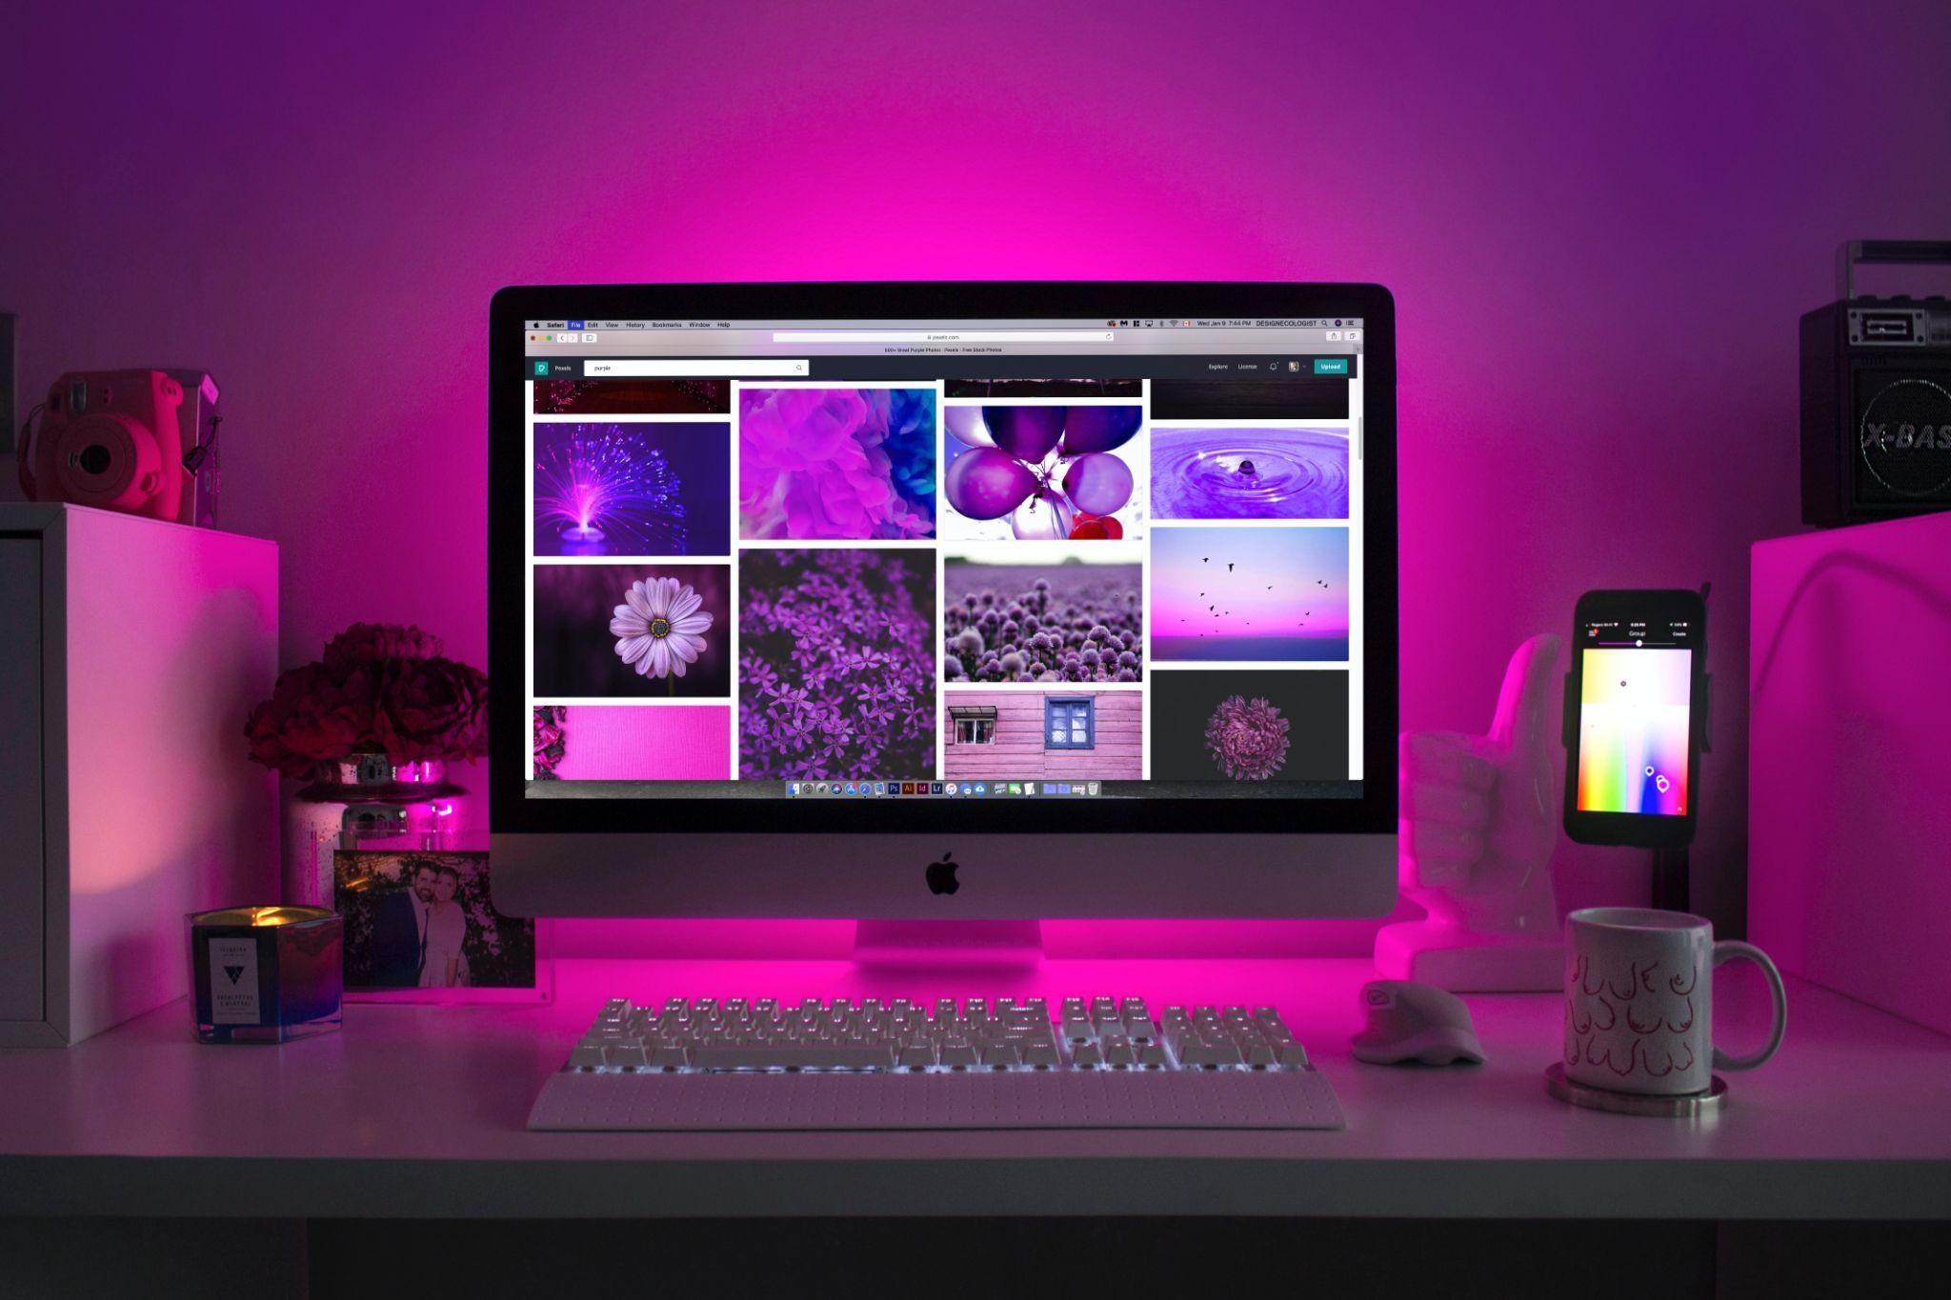

Fig 4. Unsplash (n.d.) Example of an online portfolio

Here are some websites and software suitable for creating a design portfolio:

* Adobe Portfolio
* Behance
* Wix
* Squarespace
* Cargo
* Format
* Carbonmade
* Coroflot
* Wordpress
* Dribbble

When selecting a platform, consider factors like customisation options, ease of use, and whether you need a dedicated domain name. It is also worth remembering to regularly update your portfolio with your latest and best creative work to ensure you both remain current and can impress potential clients and employers.

### Printed portfolio

A printed version of your portfolio is useful when attending an in-person interview or a pitch for new business. Printing your portfolio pages allows for easy interaction between potential clients or employers. While possessing a portfolio online is an invaluable method to quickly showcase your designs, if you work in a more print-oriented discipline, the ability to place your work directly into the hands of potential clients and employers is hugely advantageous.

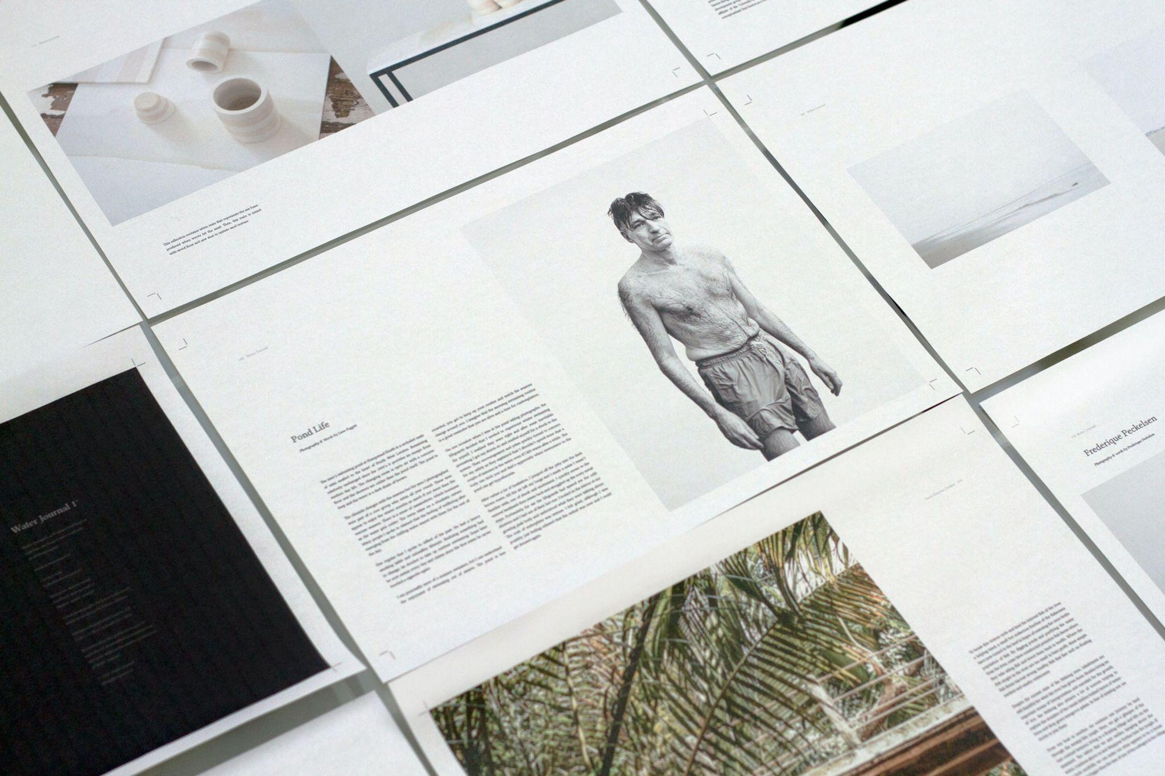

Fig 5. Unsplash (n.d.) Examples of printed work

If your focus is more on digital-based design, you will undoubtedly need to produce a digital portfolio but it’s best not to entirely depend on one version. Should your device/s lose internet connection or battery power, making you unable to present your work to your intended audience, a printed back-up portfolio could save the day. Either way, a printed portfolio can be a useful tool in a designer's arsenal.

## Supporting documentation

The portfolio should be accompanied by a CV, which should show a clear link to the portfolio to create a cohesive presentation. On your CV, ensure to show a transcript of your education and any relevant further education. The CV needs to be clear, concise, well structured and formatted, and should not show any empty gaps between education or employment. For example, a gap year could also be used to research cultural and regional differences in the use of colour in interiors and should be stated on the CV.

A professional approach is to have your own business cards. You can also use personal letter headed paper for your personal statement. References, named referees and work experience endorsements need to be available and ready to be instantly provided when required.

## Some additional portfolio considerations

* **Work showcased**

Depending on the job you are applying for or the client you are meeting, the portfolio you use to showcase your work should be tailored. Your complete portfolio may consist of a variety of examples of your work, but the one you utilise for a specific purpose should be a refined selection relative to the job/project.

* **Paper size and stock**

Your choice of page size will be based on the type of work displayed in your portfolio and its portability. For example, if you are a photographer working predominantly to create images for web-based banner ads, your pages may not need to be larger than A4. If you have done large scale print work, you may wish to display your work on an A3 page. The paper stock you choose will also affect the way in which colours and details are portrayed so be mindful of how certain colour systems will convert to CMYK (RGB and Pantone transfer).

* **Branding**

Your portfolio (digital or printed) allows you the freedom to communicate your own ‘brand’ and by doing so, allows prospective clients or employers an insight into ‘you’ as a person and a designer. You may wish to consider a logo or ‘stamp’ that can express something about you or your design style. This could include visual elements such as colours or shapes alongside your name or initials. As with all branded materials, your visual identity should be consistent throughout your portfolio regardless of whether it is printed or digital.